Weather Station

Subject: Surface area, air flow, air pressure, magnetism  Related Subjects: | Grade Level(s):k-4, 5-8  Length of Lesson: | Type: Inquiry / Design / Project  Keywords: Magnetic field, flow, vector, circumference

Lesson Overview
Use this section to describe at a high level what the lesson is. Should be no more than 3-4 lines.

Lesson Focus
Students will create a weather vane, anemometer and a compass to determine and chart wind flow directions and speed.

Lesson Objective(s) | - Students will create weather vane.  - Students will create anemometer  - Students will create water compass.  - Students will measure wind flow on various parts of campus.  - Students will record direction and speed of wind flow.  - Students will convert feet per minute to miles per hour.  - Students will mark wind flow directions and speed on enlarged campus map with vector arrows.

Lesson Timing

5 minutes | Introduce the Lesson
30 minutes | ...

Materials | - –Cardboard tray  - –3 straws  - –2 pencils  - –5-3oz cups  - –3-5oz cups  - –1-7oz cups  - –3x5card  - –1 Needle  - –2 Pins  - –Scissors  - –Stapler  - –Styrofoam  - –Water  - –Tape  - –Hot glue gun  - –Magnet  - –Toothpick  - –Calculator  - –Campus map  - –Enlarged Thomas Guide map of school area
Instructor Prep | - Step 1
Related Resources | - www.denninger.com

Lesson Plan

Introduction
Weather Vanes are used to tell the direction of wind flow. The anemometer is used to tell wind speed. The compass is used as a way to tell direction.

There are only two basic rules that must be followed when designing a weather vane: 1.) The ornament must have unequal area on either side of center. 2.) The ornament must have equal mass on either side of center. The history of weather vanes is an interesting one which spans many centuries and travels over many countries.

Excerpt from http://www.denninger.com/history.htm:
The earliest recorded weather vane honored the Greek god Triton, and adorned the Tower of the Winds in Athens which was built by the astronomer Andronicus in 48 B.C. The figure, which is believed to have been 4 to 8 feet long, had the head and torso of a man and the tail of a fish. To the ancients, the winds had divine powers. In Greece and pre-Christian Rome, weather vanes depicting the gods Boreas, Aeolus, Hermes and Mercury decorated the villas of wealthy landowners.

Archaeologists have discovered bronze Viking weather vanes from the 9th century. They have an unusual quadrant shape, usually surmounted by an animal or creature from Norse fable. They were commonly used on Viking ships, and were also popular on Scandinavian churches. These weather vanes can be seen even today in Sweden and Norway.

In the ninth century A.D., the pope reportedly decreed that every church in Europe should show a cock on its dome or steeple, as a reminder of Jesus' prophecy that the cock would not crow the morning after the Last Supper, until the disciple Peter had denounced Him three times (Luke 22:34). Because of this story, "weather cocks" have topped church steeples for centuries, both in Europe and in America. The 11th century Bayeux Tapestry even includes a scene of a craftsman attaching a rooster vane to the spire of the Westminster Abbey.

It is probably the banners which flew from medieval towers in Britain, Normandy and Germany which are the precursors to our modern weather vanes. The word "vane" actually comes from the Anglo-Saxon word "fane", meaning "flag". Originally, fabric pennants would show the archers the direction of the wind. Later, the cloth flags were replaced by metal ones, decorated with the insignia or coat of arms of the lord or nobleman, and balanced to turn in the wind. From these antecedents come the banners which the early American colonists favored for their meeting halls and public buildings.

America's first documented weather vane maker, Deacon Shem Drowne, created the famous grasshopper vane atop Boston's Faneuil Hall (1742), as well as the banner for Boston's Old North Church (1740), the rooster now on First Church in Cambridge (orig. 1721), and the large copper Indian for Boston's Province House (1716). Thomas Jefferson attached the weather vane on Monticello to a pointer in the ceiling of the room directly below, so he could read the direction of the wind from inside his home. And George Washington commemorated the end of the Revolutionary War by commissioning a "Dove of Peace" weather vane from Joseph Rakestraw in 1787, for his estate at Mount Vernon.

In the early 1800's, Americans favored weather vanes in patriotic designs, including the Goddess of Liberty, and of course, the Federal Eagle. By the middle of the century, vanes of famous racing horses like "Black Hawk", "Smuggler" and "George M. Patchen" were being modeled after the popular Currier and Ives prints. In the 19th century, there were many weather vane manufacturers mass-producing vanes in dozens of designs. Some of the more famous makers were L. W. Cushing, J. W. Fiske, Harris & Co., A. L. Jewell & Co., and E. G. Washburne & Co.

In the last decades of the 19th century, Victorian buildings had fancy weather vanes and elaborate metalwork embellishing almost every inch of roof space. We have found that Victorian style copperwork, de rigueur on Queen Anne, Second Empire, Richardsonian and Tudor buildings, is in great demand for the Victorian Revival homes of today. After 1900, the movement to a simpler style of architecture was reflected in the silhouette weather vane, which often depicted sporting scenes or figures of a humorous nature.

Use of the magnetic compass for navigation is said to have begun about the 12th century AD.

Procedure Weather Vane
- –Hot glue 7oz cup upside down to back of cardboard tray.
- –Hot glue a 5oz cup upside down to front of cardboard tray.
- –Cut a 5oz cup to 1” in height and glue to cardboard tray between other to cups.
- –Cut 4 small triangles (1/2” in height) from 3x5 card and label N,S,E,W
- –Tape triangles to bottom of a 5oz cup with in the order N, E, S and W at 90° angles. This is your direction setter.
- –From remainder of 3x5 card cut a 1”x 1.5” triangle and a 3” x 2.5” triangle.
- –Sharpen a pencil to 5” in height, and use it to poke holes into the center of the bottoms of the 7oz cup and direction setter.
- – Insert pencil into 7oz cup (with eraser pointing up) and hot glue in place.
- –Place direction setter over 7 oz cup and pencil so that it rotates.
- –Insert a stickpin through the midpoint of a straw.
- –With the pin perpendicular to the ground, make a ½“ incision on one end and a ¾“ incision on the other. The incisions should be on the same axis as the pin.
- –Insert the base of the small triangle into the ½“ incision and tape into place.
- –Insert top of large triangle in to ¾” incision and tape into place.
- –The triangles and pins should be on same axis (see figure 1).
- –Insert pin into top of pencil. Your weather vane is complete.

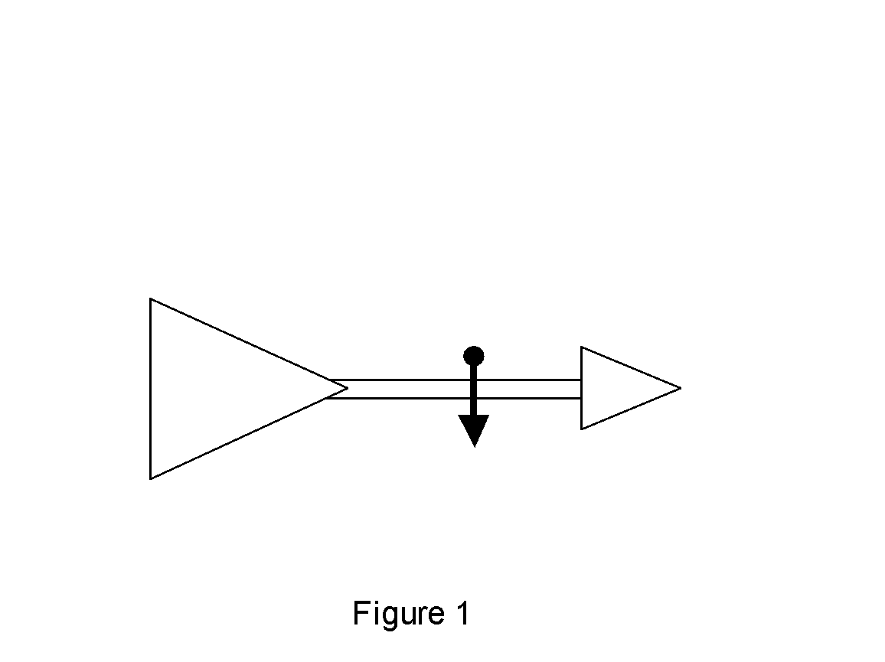

Procedure Anemometer
- –Punch one hole in four of the 3oz cups about ½“ below the rim.
- –Take the 5th 3oz up and punch 4 equally spaced holes about ¼” below the rim and a hole in the center of the bottom of the cup.
- –Insert straw through hole of one of the cups, fold the end of the straw about ¼” and staple to the other side of cup across from the hole.
- –Insert 2nd straw through hole of another of the cups, fold the end of the straw about ¼” and staple to the other side of cup across from the hole.
- –Slide straw from straw/cup through opposite holes on four hole cup.
- –Insert straw/cup straw through hole of one of the free cups, fold the end of the straw about ¼” and staple to the other side of cup across from the hole making certain that the two cups face different directions when one faces you (see figure 2).
- – Slide straw from straw/cup through other opposite holes on four hole cup.
- – Insert remaining straw/cup straw through hole of remaining free cups, fold the end of the straw about ¼” and staple to the other side of cup across from the hole making certain that the two cups face different directions when one faces you.
- –Align the four cups so that their open ends face the same direction clockwise or counterclockwise (see figure 3).
- –Push the pin through the two straws where they intersect.
- –Make a hole in the 5oz cup on cardboard tray and insert 7” sharpened pencil and hot glue in place.
- –Attach cup structure to pencil by pushing it so pencil passes through hole in center cup.
- –Push pin in straws through eraser of pencils.
- –Mark one of the spinning cups.
- –Calculate the circumference of the circle created by cups of the anemometer in feet.
- –Your anemometer is complete.
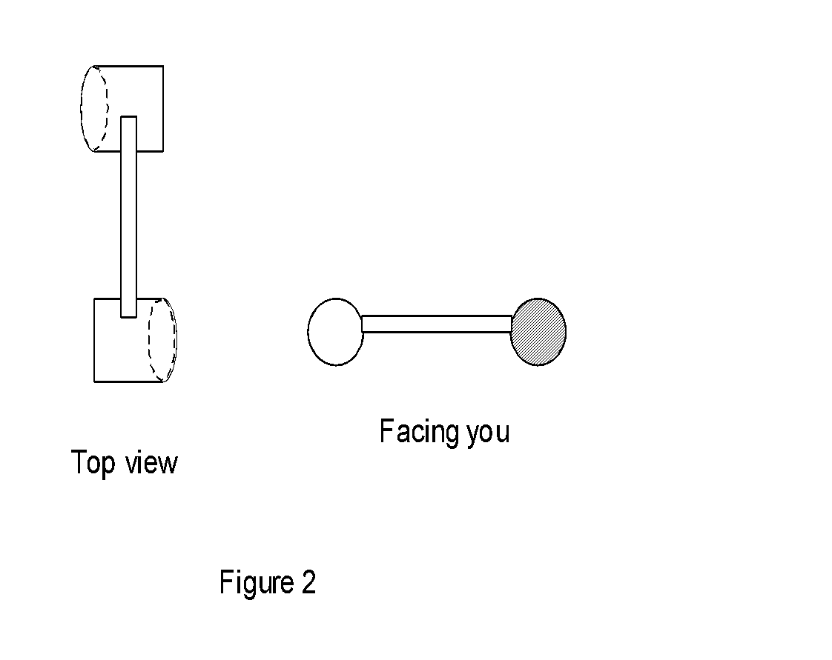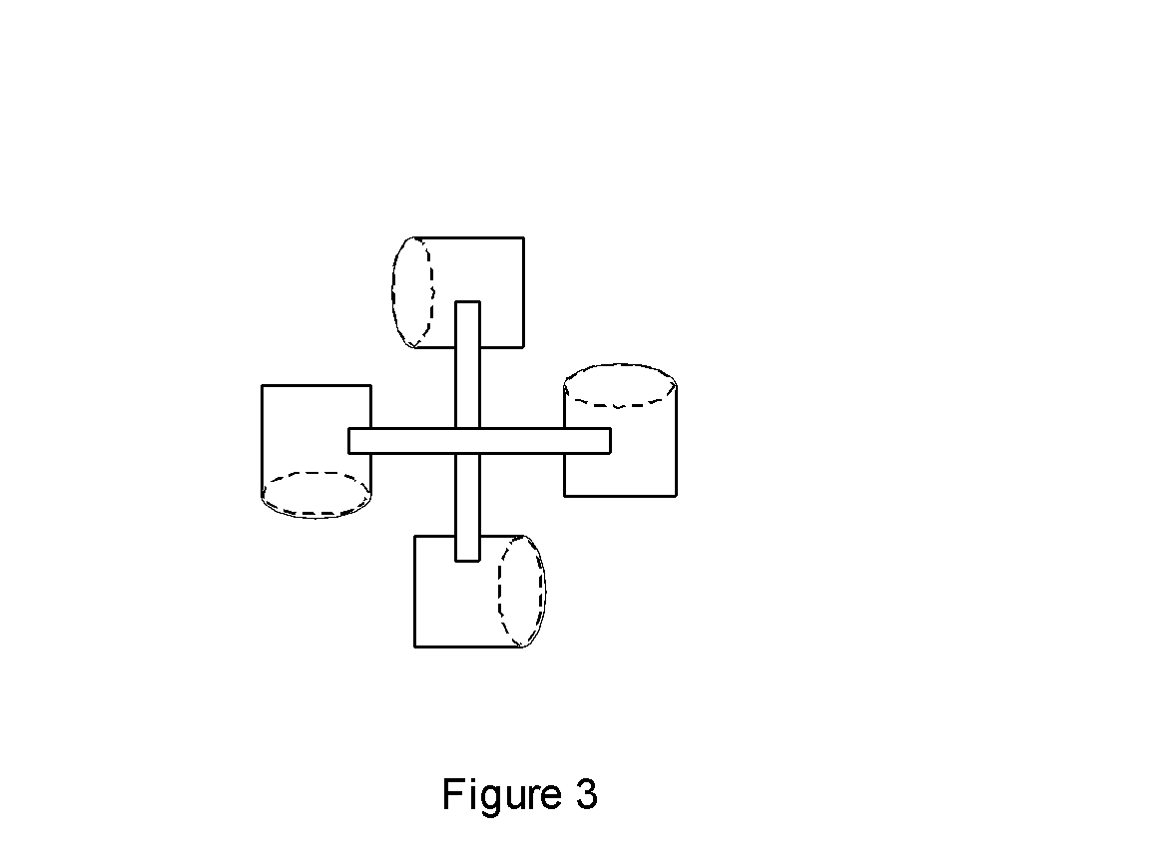

Procedure Compass
- –Break ½” from top of toothpick and glue to the center of cup ½” cut cup in middle of cardboard tray.
- –Cut a 1” diameter of Styrofoam and make small indentation on one side (this will be the bottom).
- –Rub the head of a needle against a magnet 50 times.
- –Tape the needle to the top of the Styrofoam so that its weight is equally distributed.
- –Pour water into cup until water reaches tip of toothpick.
- –Place Styrofoam on water so that it rests on toothpick.
- –Add water until the needle can turn freely, but doesn’t float off of toothpick.
- –Determine which direction is north and not which end of needle faces that direction.
- – The compass is now complete.

USING THE Weather Station

- – To take measurements, rotate direction setter so that N faces the north direction.
- –Note the direction of the wind.
- –Place Weather Station. in a stationary location where there is a wind.
- –Note the number of times the marked cups spins in 1 minute.
- –Calculate the wind speed by multiplying the revolutions per minute times the circumference of the anemometer.
- –Convert the speed to miles per hour by multiplying speed by 60 (there are 60 minutes in an hour) and by dividing by 5280 (there are 5280 feet in one mile.
- –Using the scale of ½” = 1mile, draw a vector arrow on campus map indicating direction and speed of wind in measurement location.

Wrap-up
- Students will take measurements at home at 6:30am and teacher will plot on enlarged Thomas Guide map.

Lesson Background for Teachers

Suggested Real-World STEM Connections
- List possible related Role Models in STEM (with details and links to more reading). Give suggestions for examples of scientists/engineers who are from underrepresented groups in STEM in related careers.
- List related real-world engineering problems and examples

Lesson Variations and Options
Include descriptions of alternative methods or ways to present things.

Explanation
The weather vane is one of the oldest weather tools. The part of the vane that turns into the wind is shaped like an arrow. The other end is wide so it will catch the smallest breeze. The breeze turns the arrow until it catches both sides of the wide end equally. The arrow always points into the wind and tells you the direction from which the wind is blowing.

The anemometer rotates at the same speed as the wind because its cups capture the wind and move at the same speed in a circle. Therefore it gives a direct measure of the speed of the wind. You calculate the number of revolutions per minute, circumference and you will then have the wind speed.

Magnets align themselves with the magnetic field of the Earth. The north pole of a magnet faces the North Magnetic Pole. Although the South Magnetic Pole isn’t directly aligned with the North Magnetic Pole, the south pole of magnets face it in general. By magnetizing a needle and allowing it to freely float, it will orient itself with the magnetic field of the Earth.

Key Concepts and Vocabulary
- Word 1: Grade Appropriate Definition
- Word 2: Grade Appropriate Definition

Safety Notes
- Students should exercise caution when using scissors.
- Students should exercise caution when using hot glue gun.
- Students should exercise caution when using pins and needles.

